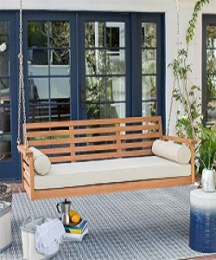

Swing

$65.35

Avilability: In stock

Description:

Classic look swing perfectly fits in any style of garden, backyard and garden decor, you can hang it anywhere in room and lounge also, it has a smooth rocking motion. The swing comes with an adjustable fabric canopy that provides UV and sunlight protection so that you and family stay cool and comfortable. You will enjoy this stylish swing as it crafted for long-lasting durability. It is a great start for transforming your garden into a secret getaway. It will stand out in your outdoor living space with its inviting design.